**Sprint 3 Plan**

**Product Name:** SummarAIze

**Sprint Completion Date:** May 20, 2025

**Revision Number:** V1.1

**Revision Date:** May 7, 2025

**Scrum Meeting Times:** M - 12:00-2pm, W - 12:00-2pm, F - 9:30am - 10:30am (Meeting with TA)

**High-Level Goal:** Focus on video generation, flesh out animation features, and implement the chatbot.

**Task Listing:**

* {3} User story 3.1 [13]
  + **As an educator, I want to be able to create a visual representation so that I can make presentations so that complex concepts are simplified for students.**
    - Task 1: Put visuals in frontend (1 hr)
    - Task 2: Research and add API to generate images (2 hr)
    - Task 3: Research and use Python libraries to create videos (3 hr)
    - Task 4: Add animation over visuals (4 hr)
    - Task 5: Integrate any visual components with the voiceover (3 hr)
* {7} User story 3.2 [13]
  + **As a user, I want to get suggestions for related research papers so that I can explore the topic further.**
    - Task 1: Parse through citations at the end of the paper (1 hr)
    - Task 2: Connect to API to fetch papers based on keywords (3 hrs)
    - Task 3: Update frontend to display suggestions (1 hr)
* {8} User story 3.3 [5]
  + **As a researcher, I want to see citations from the original paper in the summary so that I can refer back to the sources accurately.**
    - Task 1: Update prompt to LLM to add citations (2 hr)
* {9} User story 3.4 [5]
  + **As a user, I want to ask questions about the paper so that I can clear up any confusion and refine the summary.**
    - Task 1: Add another API call to allow Q&A based on summary (2 hr)
    - Task 2: Create UI for chatbot (2 hr)
    - Task 3: Allow “chatbot” to make changes to summary (3 hr)
* **Total Estimated Hours: 27 hours**

**Team Roles:**

Koena: Project Owner, Developer

Ashton: Developer

Poojitha: Developer

Amisha: Scrum Master, Developer

Nathan: Developer

**Scrum Board:**

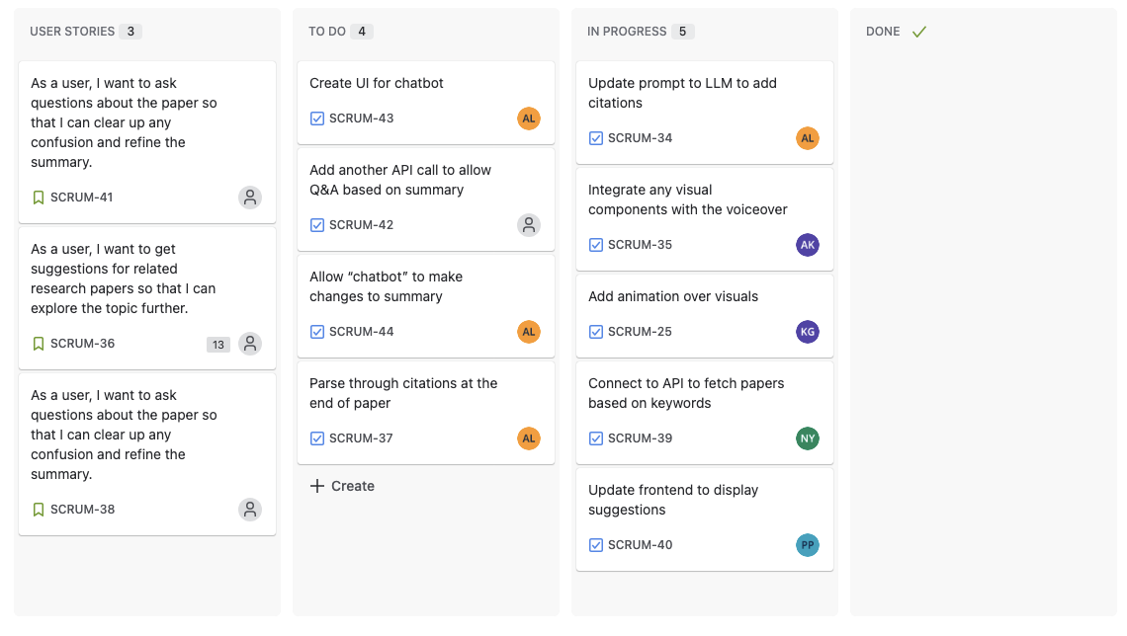

**Burn-up Chart:**

